**EXPERIMENT-8(VIRTUAL LAB-2)**

**AIM: -** To study and verify Maximum Power Transfer Theorem

**APPARATUS:**

1.     Rheostats: 50 Ω, 5A (3 Nos.)

2.     A.C Ammeter: 0 -5 Amp.

3.     A.C Voltmeter: 0-230 volts (2 Nos.)

**CIRCUIT DIAGRAM:**

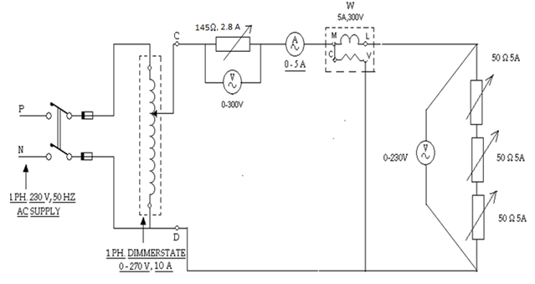

**THEORY:**

This theorem states that -

"In an active network of impedances maximum power is transferred to the load when the load impedance equals the complex conjugate of an equivalent source impedance of the network as viewed from the terminals of the load."

Consider the network shown in the fig a.

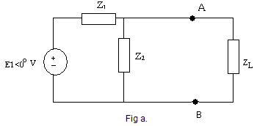

Let Zeq is the equivalent impedance of the network as viewed from the terminals AB replacing all the independent sources by their internal impedances as shown in fig b.

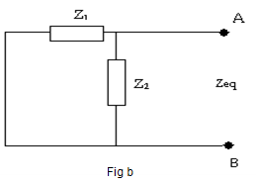

Let this Zeq = Z1 || Z2 = R+jX

Then the maximum power is transferred to the load, if ZLis complex conjugate of Zeq.

Mathematically ZL = Zeq*

So ZL = R-jX

Thus for maximum power transfer to the load, the resistance of load and resistance part of Zeq must be same while the reactance of load and Zeq must same in magnitude but of opposite in sign. So if Zeq reactance is inductive, ZL must be capacitive and vice versa.

**OBSERVATION:**

**READING 1-**

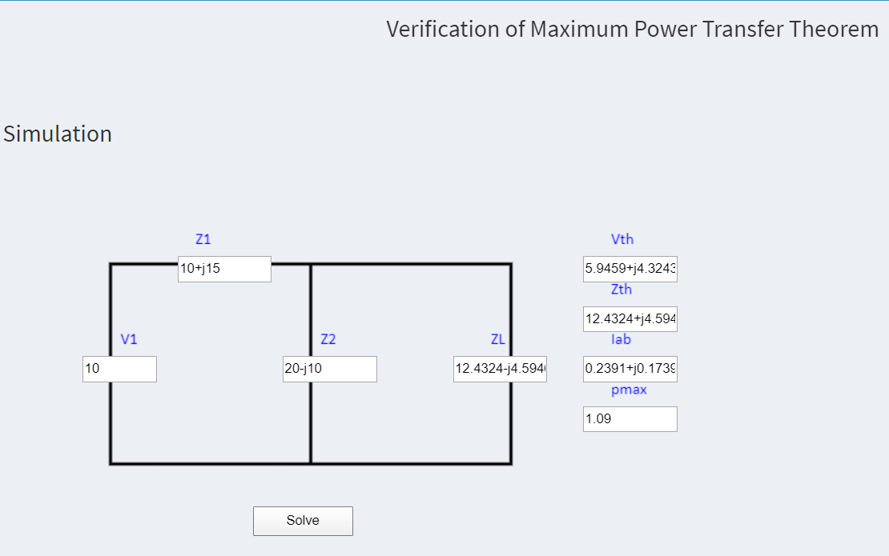

**READING 2-**

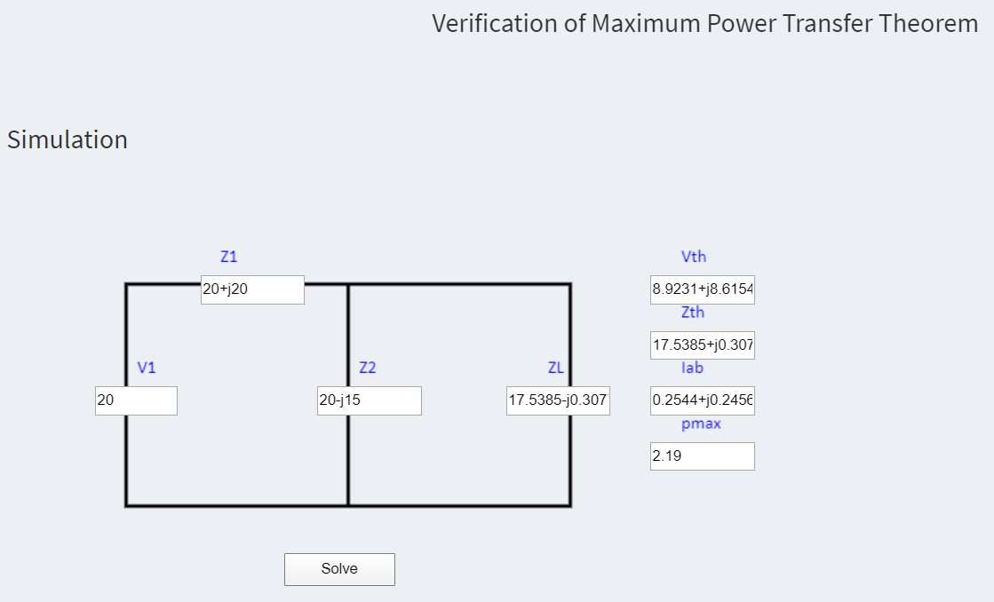

**READING 3-**

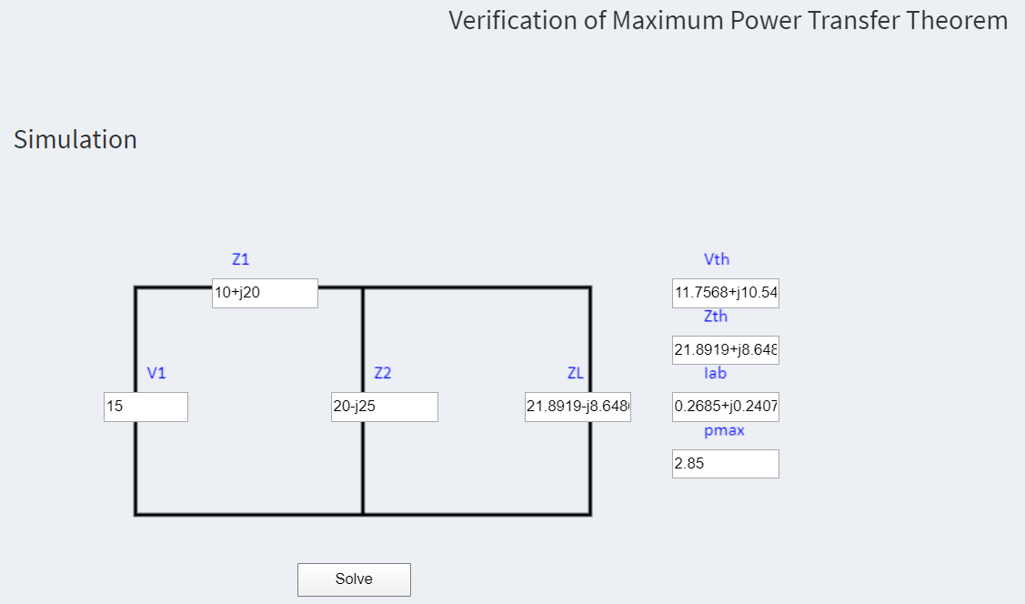

**RESULT:**

It is verified from ZL& ZTH that RL = RS for maximum power transfer.  
 Hence maximum power transfer theorem is verified.